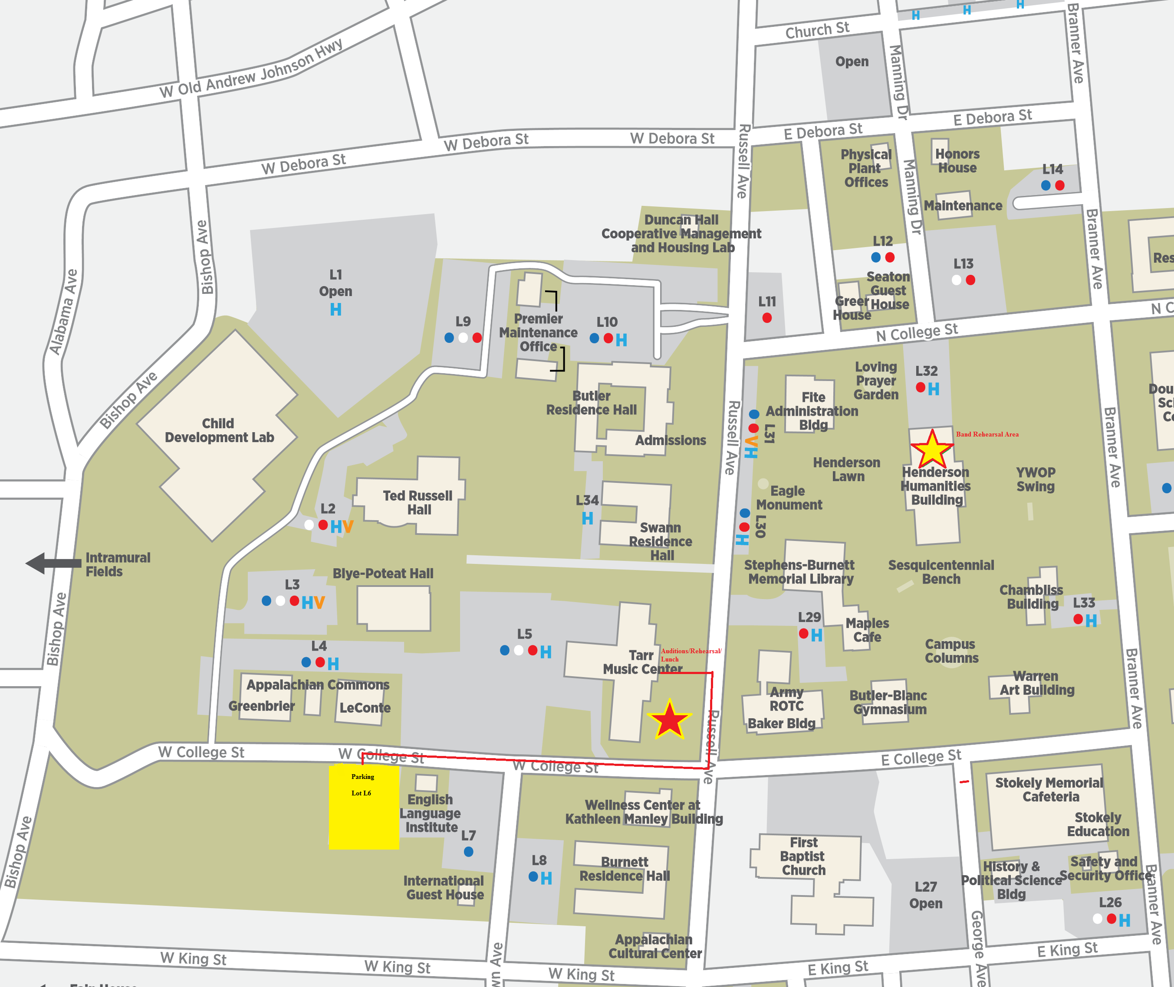
- All Vehicle Parking is in the Yellow Highlighted Area. Lot L6
- Warm-Up and Audition Rooms in Tarr Music Center
- Rehearsal Areas: Henderson Humanities Building 1st Floor; Tarr Music Ctr. Rm. 117 (Band Rm)
Directions from Johnson City/Tri-cities
- Get on I-26 W/US-23 N
- Take I-81 S to TN-341
- Take exit 4 White Pine Rd from I-81 S
- Take Chucky Pike to Russell Ave in Jefferson City
- Turn right onto TN-341 W
- Turn left onto TN-66 S/Valley Home Rd
- Turn right onto Chucky Pike
- Turn left to stay on Chucky Pike
- Turn left onto E Old A J Hwy/E Old Andrew Johnson Hwy
- Turn left onto Russell Ave
- 1620 Russell Ave

Directions from Knoxville
- Get on I-40 East toward Asheville
- Take exit 394 for US-11E/US-25W/US-70
- Use the left 2 lanes to turn left onto US-11E N/US-25W S/US-70 E
- Keep left to continue on US-11E N for 15 miles
- Turn left onto Russell Ave
- 1620 Russell Ave

